“**Experiment 1.6”**

**Student Name: SUMIT KUMAR UID: 20BCS8226**

**Branch: CSE Section/Group:DM-720 A**

**Subject Name: MAD Lab Subject Code: 20CSP-356**

**AIM:**

Create an Android-based application and use Intent to send SMS.

**Requirements:**

Android Studio.

## Script and Output: XML CODE:

<?xml version="1.0" encoding="utf-8"?>

<androidx.constraintlayout.widget.ConstraintLayout xmlns:android="<http://schemas.android.com/apk/res/android>"

xmlns:app=["ht](http://schemas.android.com/apk/res-auto)t[p://schemas.android.com/apk/res-auto](http://schemas.android.com/apk/res-auto)" xmlns:tools="<http://schemas.android.com/tools>" android:layout_width="match_parent" android:layout_height="match_parent" android:background="#000000" tools:context=".MainActivity">

<Button

android:id="@+id/button" android:layout_width="115dp" android:layout_height="55dp" android:backgroundTint="#D0D68D" android:fontFamily="sans-serif-smallcaps" android:text="SEND"

/>

<EditText android:id="@+id/phone" android:layout_width="282dp" android:layout_height="60dp"

android:layout_marginTop="224dp" android:background="#A6939A" android:ems="10" android:fontFamily="sans-serif-smallcaps" android:hint="+91 ***** *****"

/>

<TextView android:id="@+id/textView6" android:layout_width="258dp" android:layout_height="45dp" android:layout_marginTop="112dp"

android:fontFamily="sans-serif-smallcaps" android:text="Phone Number" android:textAlignment="center" android:textColor="#FFFFFF" android:textSize="22sp"

/>

<EditText android:id="@+id/message" android:layout_width="330dp" android:layout_height="136dp" android:background="#A6939A" android:ems="10"

android:fontFamily="sans-serif-smallcaps" android:hint="Your Message" android:inputType="textMultiLine"

android:textAlignment="center" android:textColor="#FFFFFF" android:textColorHint="#FFFFFF" app:layout_constraintStart_toStartOf="parent" app:layout_constraintTop_toBottomOf="@+id/phone" app:layout_constraintVertical_bias="0.566" />

</androidx.constraintlayout.widget.ConstraintLayout>

# JAVA CODE:

package com.example.experiment_6;

import androidx.appcompat.app.AppCompatActivity; import android.annotation.SuppressLint;

import android.widget.EditText;

public class MainActivity extends AppCompatActivity { EditText phone,msg;

@SuppressLint("MissingInflatedId") @Override

protected void onCreate(Bundle savedInstanceState) { super.onCreate(savedInstanceState); setContentView(R.layout.activity_main); phone=findViewById(R.id.phone); msg=findViewById(R.id.message);

}

public void sendSms(View view)

{

String number,message;

number=phone.getText().toString(); message=msg.getText().toString();

Intent i = new Intent(Intent.ACTION_VIEW, Uri.parse("sms:"+ number)); i.putExtra("sms_body",message);

startActivity(i);

}

}

**OUTPUT:**

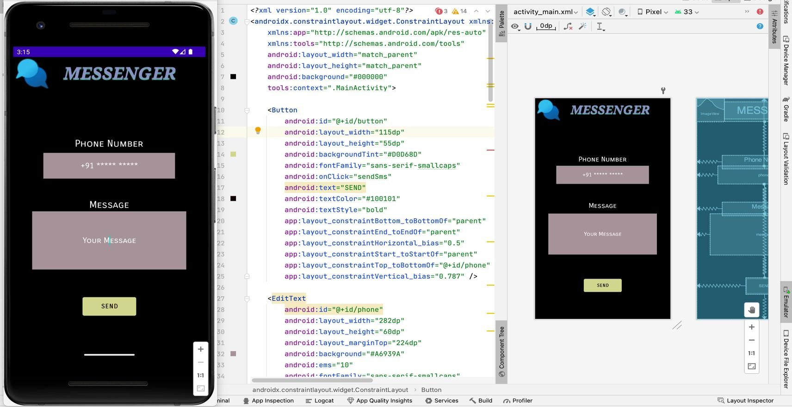

# SCREENSHOTS:

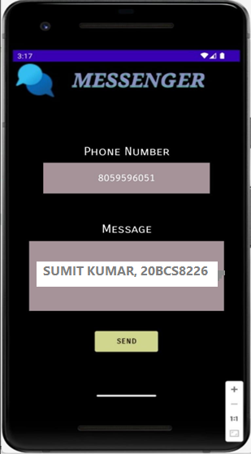 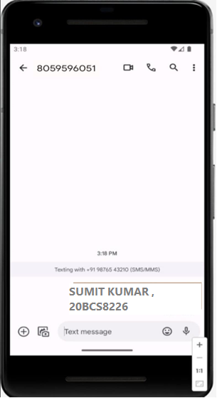

# Learning Outcomes:

* Learnt the use of Intent in Android Studio.
* Learnt to Build the application to perform the use of Intents.
* Learnt how to send SMS using Intent.